**Appendix User Guide**

**User Manual – Employee management system**

**Content**

Understand the program

How to use the program

Examples

**Understand the program**

The program is meant to be used for managing employees, their schedules and register their working hours

The data is stored inside the database which is accessed through the server and all operations are made inside GUI

**How to use the program**

The program requires java 1.11 or newer.

The program requires postgresql-42.2.5.jar to be downloaded and included in modules

The program requires user to create a database and execute a script inside the folder

The user has to manually create administrator user inside the database

The program is started by firstly running MainServer class and then GUI can be launched by starting Main class

**Administrator adds an employee**

Administrator through the GUI will fill required textfields seen on the image

**Adding an employee with GUI**

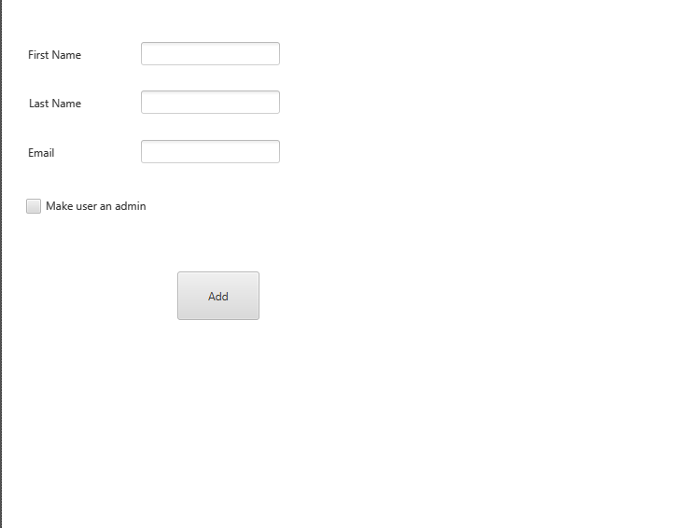

**Employee is added and can be displayed inside GUI**

**Administrator lists all employees**

Administrator goes to manage employee tab and the list of all employees inside the database is displayed

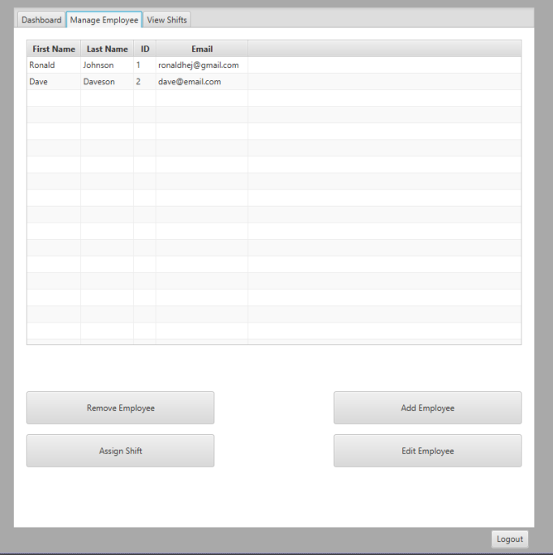

**Employee views his schedule**

An employee firstly logs onto his account, once his credentials are verified he is taken to his main screen with his schedule visible.

